Southwest SWODA WIB

P.O. Box 569
Burns Flat, Oklahoma 73624
Occupation Overview Report

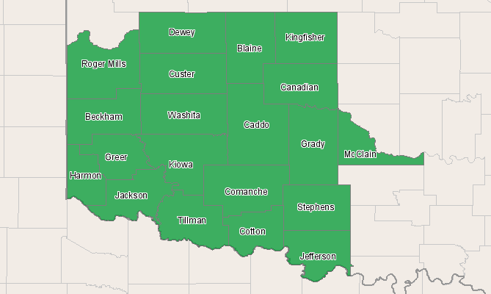

Economic Modeling Specialists, Inc. www.economicmodeling.com


Region Info

Region: SOIC
County Areas: Beckham, Oklahoma (40009), Blaine, Oklahoma (40011), Caddo, Oklahoma (40015), Canadian, Oklahoma (40017), Comanche, Oklahoma (40031), Cotton, Oklahoma (40033), Custer, Oklahoma (40039), Dewey, Oklahoma (40043), Grady, Oklahoma (40051), Greer, Oklahoma (40055), Harmon, Oklahoma (40057), Jackson, Oklahoma (40065), Jefferson, Oklahoma (40067), Kingfisher, Oklahoma (40073), Kiowa, Oklahoma (40075), McClain, Oklahoma (40087), Roger Mills, Oklahoma (40129), Stephens, Oklahoma (40137), Tillman, Oklahoma (40141), Washita, Oklahoma (40149)
Occupation Size and Growth

2010 - 2015 Size and Growth
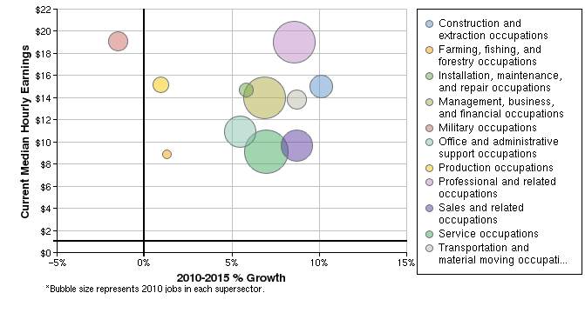

Description | 2010 Jobs | 2015 Jobs | Growth | % Growth | Current Median Hourly Earnings
Construction and extraction occupations | 19,012 | 20,937 | 1,925 | 10% | $14.98
Farming, fishing, and forestry occupations | 3,278 | 3,320 | 42 | 1% | $8.86
Installation, maintenance, and repair occupations | 10,468 | 11,076 | 608 | 6% | $14.67
Management, business, and financial occupations | 43,273 | 46,240 | 2,967 | 7% | $13.99
Military occupations | 16,547 | 16,294 | -253 | -2% | $19.07
Office and administrative support occupations | 30,389 | 32,054 | 1,665 | 5% | $10.96
Production occupations | 12,889 | 13,012 | 123 | 1% | $15.20
Professional and related occupations | 41,193 | 44,726 | 3,533 | 9% | $18.98
Sales and related occupations | 30,544 | 33,208 | 2,664 | 9% | $9.63
Service occupations | 43,848 | 46,899 | 3,051 | 7% | $9.15
Transportation and material moving occupations | 15,465 | 16,816 | 1,351 | 9% | $13.86
Total | 266,905 | 284,581 | 17,676 | 7% | $13.52
Source: EMSI Complete Employment - 2nd Quarter 2010

2010 Occupational Makeup
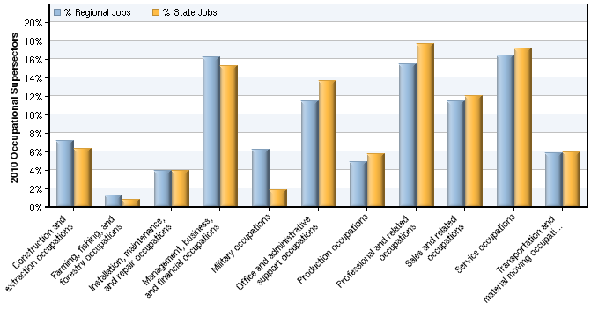

Description | 2010 Regional Jobs | % Regional Jobs | 2010 State Jobs | % State Jobs
Construction and extraction occupations | 19,012 | 7.1% | 131,961 | 6.3%
Farming, fishing, and forestry occupations | 3,278 | 1.2% | 16,112 | 0.8%
Installation, maintenance, and repair occupations | 10,468 | 3.9% | 81,784 | 3.9%
Management, business, and financial occupations | 43,273 | 16.2% | 320,413 | 15.2%
Military occupations | 16,547 | 6.2% | 38,736 | 1.8%
Office and administrative support occupations | 30,389 | 11.4% | 287,419 | 13.6%
Production occupations | 12,889 | 4.8% | 120,413 | 5.7%
Professional and related occupations | 41,193 | 15.4% | 371,772 | 17.6%
Sales and related occupations | 30,544 | 11.4% | 253,643 | 12.0%
Service occupations | 43,848 | 16.4% | 361,807 | 17.2%
Transportation and material moving occupations | 15,465 | 5.8% | 125,064 | 5.9%
Source: EMSI Complete Employment - 2nd Quarter 2010

Data Sources and Calculations

Occupation Data

Organizing regional employment information by occupation provides a workforce-oriented view of the regional economy. EMSI's occupation data are based on EMSI's industry data and regional staffing patterns taken from the Occupational Employment Statistics program (U.S. Bureau of Labor Statistics). Wage information is partially derived from the American Community Survey. The occupation-to-program (SOC-to-CIP) crosswalk is based on one from the U.S. Department of Education, with customizations by EMSI.
State Data Sources

This report uses state data from the following agencies: Oklahoma Employment Security Commission.

